**Different Views on a Computer Program**

* A Computer program is a set of instructions written for the computer, in a special language, for the purpose of carrying out a Data processing task and tell computer what to do.
* A Computer program refers to the set of instructions, that describes the logical steps for a computer to perform a given task.
* A Computer program is a step-by-step instruction that tells the computer what to do, to obtain an accurate result for any task given.
* A Computer program can be described as a series of instructions that run the computer, and make the hardware function properly.
* **Computer program**, detailed plan or procedure for solving a problem with a computer; more specifically, an unambiguous, ordered sequence of computational instructions necessary to achieve such a solution.
* A sequence of instructions, stored in any medium, that can be interpreted and executed by a computer; -- called most frequently a program. This term is used both for the written program (a document) and for its corresponding electronic version stored or executed on the computer. See instruction; as, Version 1.0 of the program had a serious bug that caused the computer to crash frequently..

The **software development process** is no exception here. If you follow the well-tested software development processes, you are sure to build amazing software. According to a survey by GoodFirms, adapting to the changing client requirements is the most challenging part of the development process for software developers.

Being a leading [**software development company**](https://www.spaceotechnologies.com/services/custom-software-development/), we decided to solve these issues once and for all. In this article, you will read about what software development lifecycle is, what are stages of the software development process, types of development models, what are their pros and cons and who should go for it. We will also answer some of the most commonly asked questions here.

Contents

**What is SDLC (Software Development Life Cycle)?**

In order to understand SDLC, let’s first understand what **What is software development process**. In simple words, the software development process is dividing the software development into tiny, sequential steps to enhance the product, project, and design altogether. the iterative logical process for software program development or application development to cater to the needs of any business or personal objectives is known as ‘Software Development’.

We know that software developers use [app development software](https://www.spaceotechnologies.com/blog/app-development-software/) to create a specific code for any software development or application development. However, coding is only a part of a big process called the software development process or life cycle. The entire software development cycle consists of ideation, research, coding, documenting, testing, debugging, deployment, and updating, used by the software industry.

The software industry uses SDLC as it helps to produce high-quality software to meet customer expectations and perform rapid application development to complete within the given time and cost estimates.

Now that you have understood the definition of SDLC, it is now time to understand the 6 stages of the software development process.

**6 Stages of Software Developm**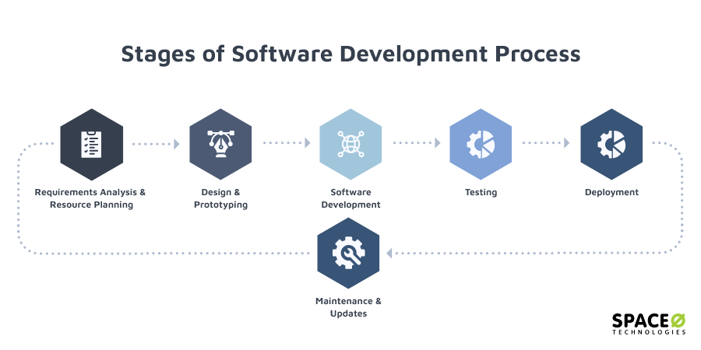

The following section shows the different stages of software development. Have a check.

1. **Requirements Analysis and Resource Planning**

The first step to any process is always planning. Being a project manager, you might have done a requirement analysis of your project, but you are going to need software engineering experts to create a [software development plan](https://www.spaceotechnologies.com/blog/software-development-plan/) for your project.

You need to analyze if the software, you are planning to develop, aligns with your business or personal goals. This is a requirements analysis. The purpose of any software is to make the tasks easier. So, you must check which tasks you are trying to optimize and how the software will help you in this.

After this, you need to allocate resources for **software development process**. You need to decide what kind of resources you will need in order to complete it. You can plan the number of project managers, software engineers, designers, tools, and technologies required for the project. Then, you need to create a flexible yet justifiable budget.

1. **Design and Prototyping**

After the analysis and planning part is over, it is time to start creating a software architecture for the product. This architecture or design will define the complete workflow of the software. In terms of software, the design doesn’t only have to do about the look but also about the overall functioning and user experience of the software.

You can play an important part in the design process as you need to explain to the software designers what is that you want from the program. You can define how the users will interact with the software application/product. The designers will design simple wireframes to show these interactions using various tools like **Adobe and InVision**. If needed, you can also have complete prototypes that display each and every functionality of the product.

In this stage, you can check if there are any drawbacks or lack of any features. You can easily make changes in this stage and start with development when everything is finalized.

1. **Software Development**

Development in software-process only begins when you are completely sure of the requirements and onboard with the design and features. The development team starts working on the development of a program by writing the necessary code.

Now, the development is carried out in different manners based on the type of software requirements. You will understand it in the software development life cycles models section below.

This is the riskiest phase of the software development process. However, being an experienced software development company, we easily understand the requirements and develop a product up to the expectations.

1. **Testing**

This is actually a continuous **process of software development**, and testing is performed alongside development. Testing is done to check the functionality, usability, and stability of the product under the rapid development process.

We have a team of quality assurance testers or QA testers. This team tests every piece of code created by the software development team. This is done both manually as well with automated tools to find out if there are any bugs or glitches.

Later, bugs are fixed by changing or adding new code to the original code. We make sure that your final product runs smoothly on the preferred devices and has all the required features and functionalities as discussed.

1. **Deployment**

This is a crucial stage in the software development life cycle. After coding and testing are done, the next development phase is to deploy your software on the necessary servers and devices. This is only done after you have approved of the product functionality and the stability of the product is proved.

Many times, the product is given an Alpha release. A small bunch of users use the product and give their feedback. After analyzing the feedback, modifications are made to the software and then released as a Beta release. Now, more users have access to the software program.

1. **Maintenance and Updates**

As described earlier, software development is a cycle. It is an iterative process of software development. After launching the product, the process is not complete. You need to keep a track of software maintenance and keep upgrading it. You need to consistently monitor software development and suggest changes whenever required.

This is done because technology keeps advancing and in order to keep up with these changes, the software products are needed to be updated. As time passes, users have different requirements that are uncovered. Further, user feedback also plays an important role in devising future updates for any software product.

Finally, we also create software that is easily scalable for future scale-ups or scale-down according to the changing trends and requirements.